Horsewyse Hoodies Order Form
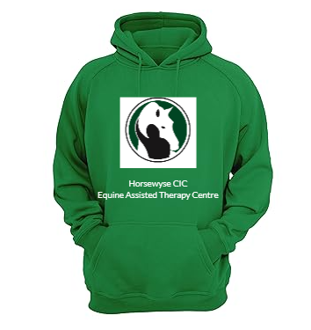(Example)

Name : ……………………………..
Colour (please circle): Black Green Navy Graphite Grey Pink Red Blue White
Size (Please circle): Small Medium Large Extra Large Extra Extra Large

Name to be printed on back ……………………………………….
Price £35.00 per hoodie.
Payable
Cash
Or
Horsewyse CIC
Account number 21491962
Sort Code: 404451
Reference : Hoodie and Name

